CAUVERY COLLEGE FOR WOMEN (AUTONOMOUS), TRICHY-18
SWAYAM NPTEL - ONLINE COURSE - FACULTY LIST
2018-2019

Number of faculty Registered and Cleared: 07

NAME | DEPARTMENT | COURSE | GRADE
Dr. K. Reka | Computer Science | Big Data Computing | Elite + Silver with Topper
Dr. M. Anandhi | Information Technology | Joy of Computing Using Python | Elite + Silver
Dr. A. Bhuvaneswari | Information Technology | Joy of Computing Using Python | Elite + Silver
Ms. M. Thangam | Information Technology | Joy of Computing Using Python | Elite + Silver
Dr. V. Sangu | Chemistry | Chemical Principles II | Elite + Silver
Dr. A. Bhuvaneswari | Information Technology | Introduction to Internet of Things | Elite
Ms. M. Thangam | Information Technology | Introduction to Probability and Statistics | Successfully Completed
Ms. B. Thanuja | FSM | Novel Technologies for Food Processing and Shelf Life Extension | Successfully Completed

ELITE + SILVER WITH TOPPER

ELITE + SILVER

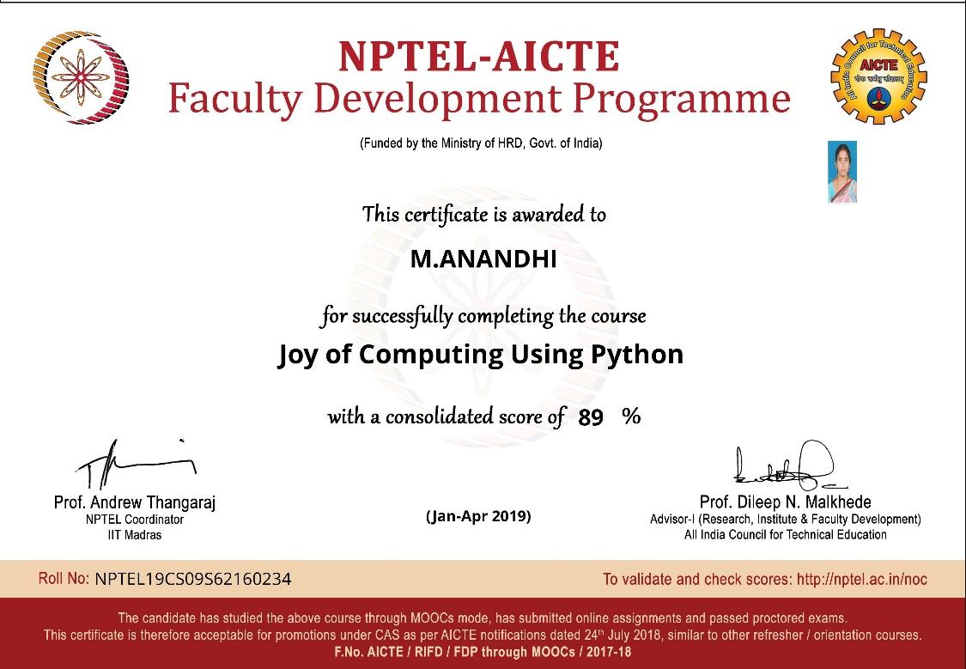

ELITE + SILVER

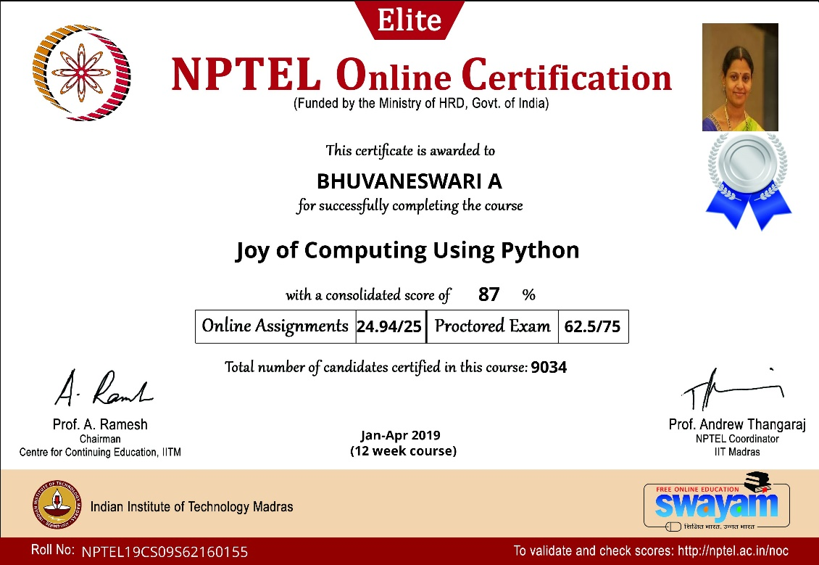

ELITE + SILVER

ELITE + SILVER

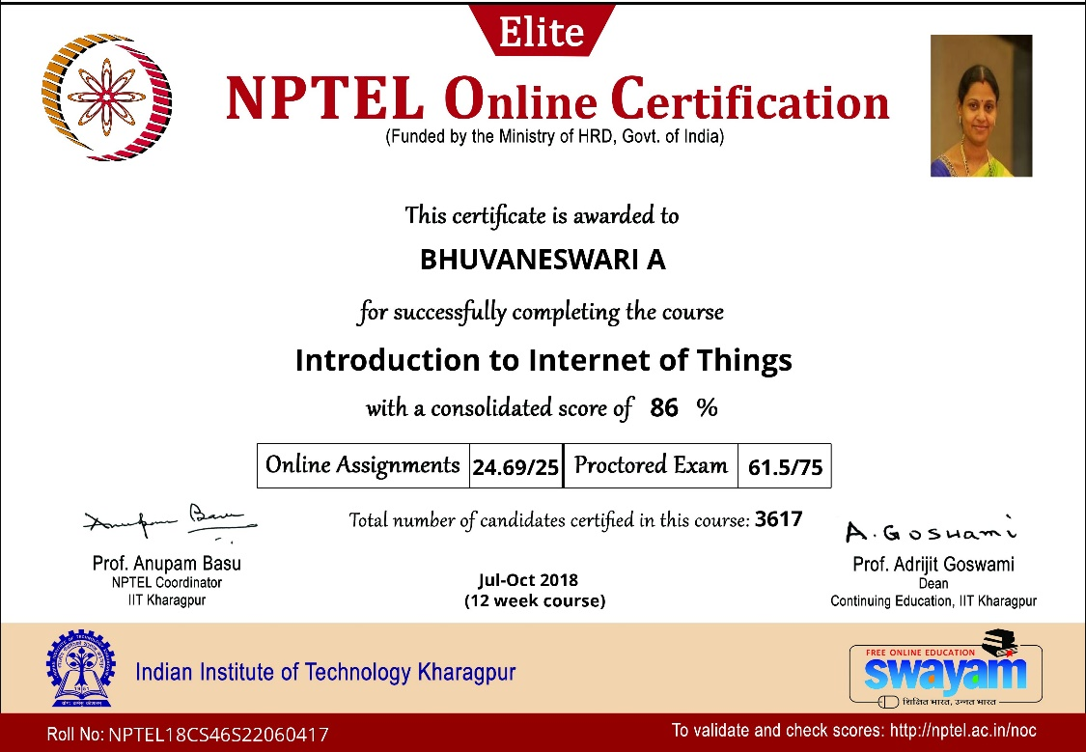

ELITE + SILVER

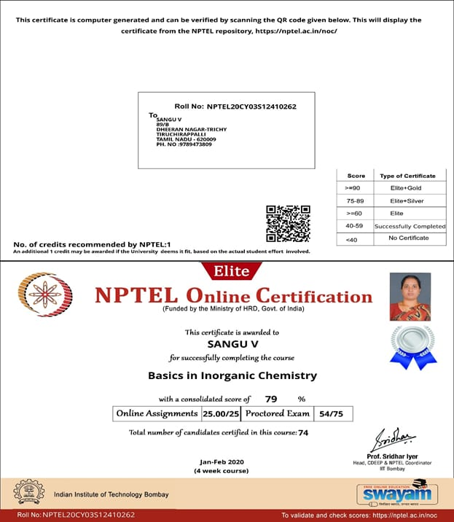

SUCCESSFULLY COMPLETED

