CAUVERY COLLEGE FOR WOMEN (AUTONOMOUS), TRICHY-18
SWAYAM NPTEL - ONLINE COURSE - FACULTY LIST
June 2019 - May 2020

For the academic year 2019-2020 totally 62 faculty members were registered for the NPTEL course and 50 got certified.

ELITE + GOLD with TOPPER: 1
ELITE + GOLD: 3
ELITE + SILVER: 16
ELITE: 20
SUCCESSFULLY COMPLETED: 10
NAME | DEPARTMENT | COURSE | GRADE
Dr. Bhuvaneswari. P | Microbiology | Biomedical Nanotechnology | Elite + Gold with Topper
Dr. V. Sangu | Chemistry | Bioenergy | Elite + Gold
Dr. Rajarajeswari. C | Chemistry | Bioinorganic Chemistry | Elite + Gold
Ms. Durgadevi P.K | English | The Psychology of Language | Elite + Gold
Dr. S. Suguna Devi | Information Technology | The Joy of Computing Using Python | Elite + Silver
Dr. P. Tamilselvi | Information Technology | The Joy of Computing Using Python | Elite + Silver
Ms. M. Gowri Sudha | Computer Science | Introduction to Internet of Things | Elite + Silver
Dr. S. Jayashree Agarwal | English | Developing Soft Skills and Personality | Elite + Silver
Dr. J. Tamilselvi | BBA | Intellectual Property Rights and Competition Law | Elite + Silver
Dr. S. Thamarai Selvi | BBA | Intellectual Property Rights and Competition Law | Elite + Silver
Dr. M. Neela | BBA | Intellectual Property Rights and Competition Law | Elite + Silver
Ms. A. Sivaranjani | BBA | Intellectual Property Rights and Competition Law | Elite + Silver
Ms. M. Gayathri | BBA | Intellectual Property Rights and Competition Law | Elite + Silver
Ms. R. Sridevi | BCA | Introduction to Internet of Things | Elite + Silver
Dr. B. Thamilmaraiselvi | Microbiology | Organic Farming for Sustainable Agriculture Production | Elite + Silver
Dr. N. Pushpa | Microbiology | Functional Genomics | Elite + Silver
Ms. N. Jeenathunisa | Microbiology | Bioenergy | Elite + Silver
Dr. V. Sangu | Chemistry | Basics in Inorganic Chemistry | Elite + Silver
Dr. K. Kalaiarasi | Mathematics | Higher Engineering Mathematics | Elite + Silver
Ms. R. Soundaria | Mathematics | Introduction to R Software | Elite + Silver
Ms. P. Muthulakshmi | Computer Science | Introduction to Internet of Things | Elite
Ms. S. Udhaya Priya | Computer Science | Introduction to Internet of Things | Elite
Ms. Rite Jenifer | Computer Science | Introduction to Internet of Things | Elite
Dr. R. Bhuvaneswari | Mathematics | Higher Engineering Mathematics | Elite
Ms. R. Divya | Mathematics | Matrix Analysis with Applications | Elite
Ms. R. Soundaria | Mathematics | Higher Engineering Mathematics | Elite
Ms. V. Mani Mozhi | Mathematics | Introduction to Abstract and Linear Algebra | Elite
Ms. S. Vidhya | Mathematics | Matrix Analysis with Applications | Elite
Ms. Yoga. N | English | History of English Language and Literature | Elite
Ms. Samyuktha. L | English | History of English Language and Literature | Elite
Dr. J. Tamilselvi | BBA | E-Business | Elite
Dr. M. Neela | BBA | E-Business | Elite
Ms. A. Suganya | BBA | Intellectual Property Rights and Competition Law | Elite
Ms. N. Sathammai Priya | Microbiology | Biomedical Nanotechnology | Elite
Dr. Steffi Francis | Microbiology | Biomedical Nanotechnology | Elite
Dr. S. Jeyabharathi | Microbiology | Organic Farming for Sustainable Agriculture Production | Elite
Dr. S. Jeyabharathi | Microbiology | Industrial Biotechnology | Elite
Dr. R. Nithyatharani | Microbiology | Organic Farming for Sustainable Agriculture Production | Elite
Ms. K. Sangeetha | Microbiology | Organic Farming for Sustainable Agriculture Production | Elite
Ms. N. Jeenathunisa | Microbiology | Plastic Waste Management | Elite
Ms. V. Geetha | Mathematics | Higher Engineering Mathematics | Successfully Completed
Ms. A. Gowri Shankari | Mathematics | Higher Engineering Mathematics | Successfully Completed
Dr. S. Sasikala | Mathematics | Higher Engineering Mathematics | Successfully Completed
Dr. R. Meenakshi | Physics | Solid State Physics | Successfully Completed
Ms. J. Aarthi | Physics | Solid State Physics | Successfully Completed
Ms. Cecilia Merlin Wilton | English | Indian Fiction in English | Successfully Completed
Ms. P. Helan Jona | English | Indian Fiction in English | Successfully Completed
Ms. V. Aruna | Microbiology | Organic Farming for Sustainable Agriculture Production | Successfully Completed
Ms. S. Sathya | Microbiology | Organic Farming for Sustainable Agriculture Production | Successfully Completed
Ms. B. Thanuja | FSM | Health Research Fundamentals | Successfully Completed

ELITE + GOLD WITH TOPPER

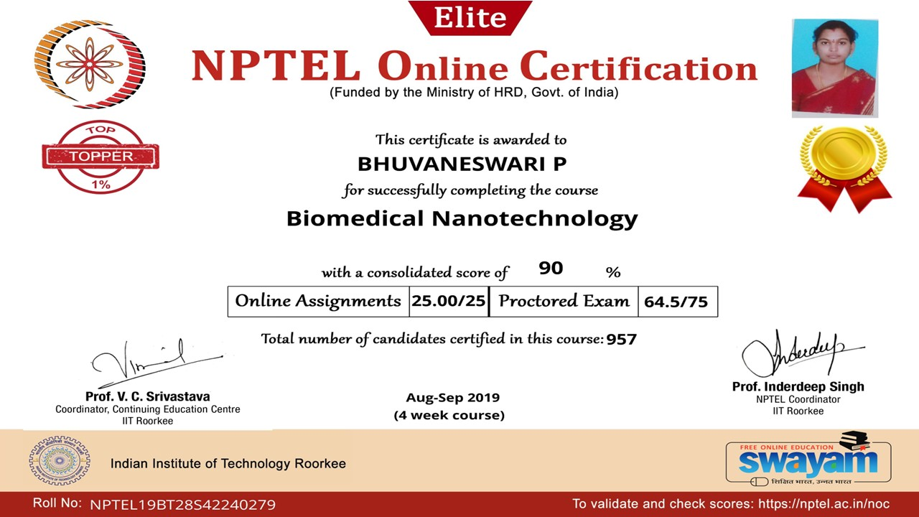

ELITE + GOLD

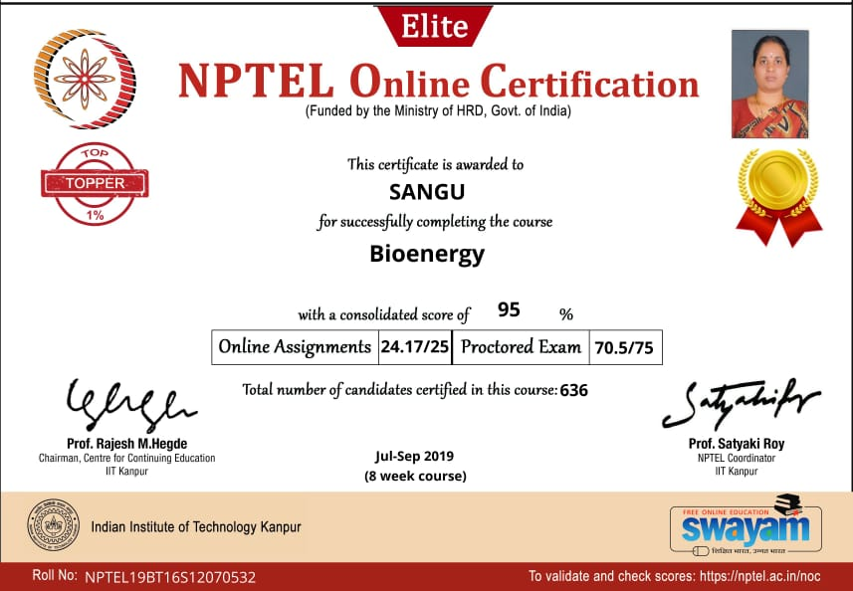

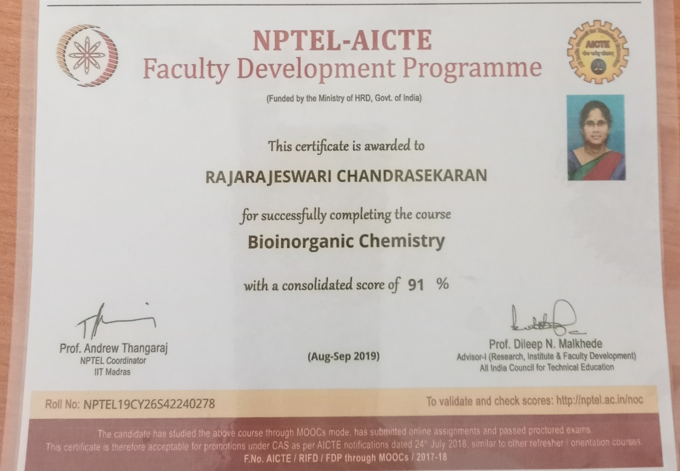

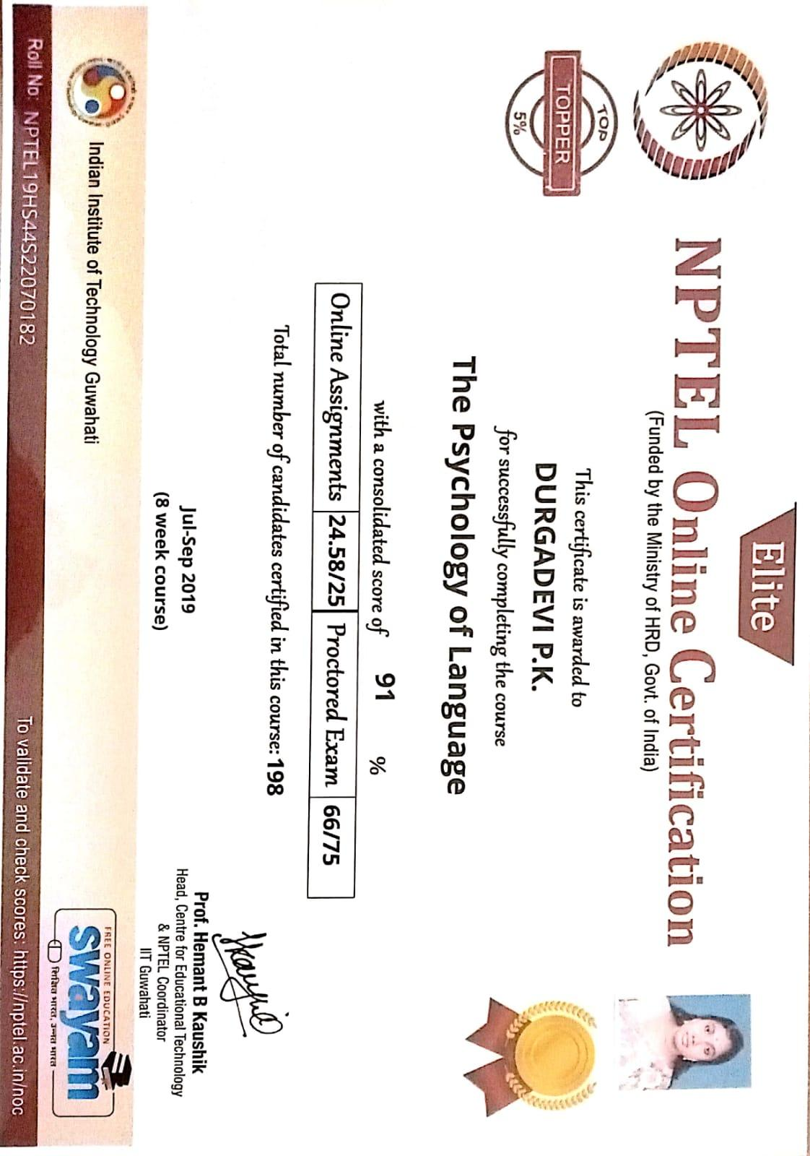

ELITE + SILVER

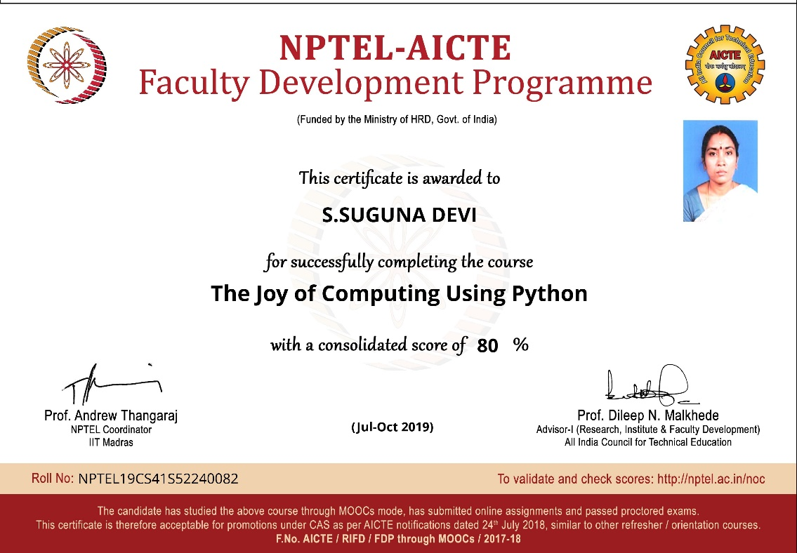

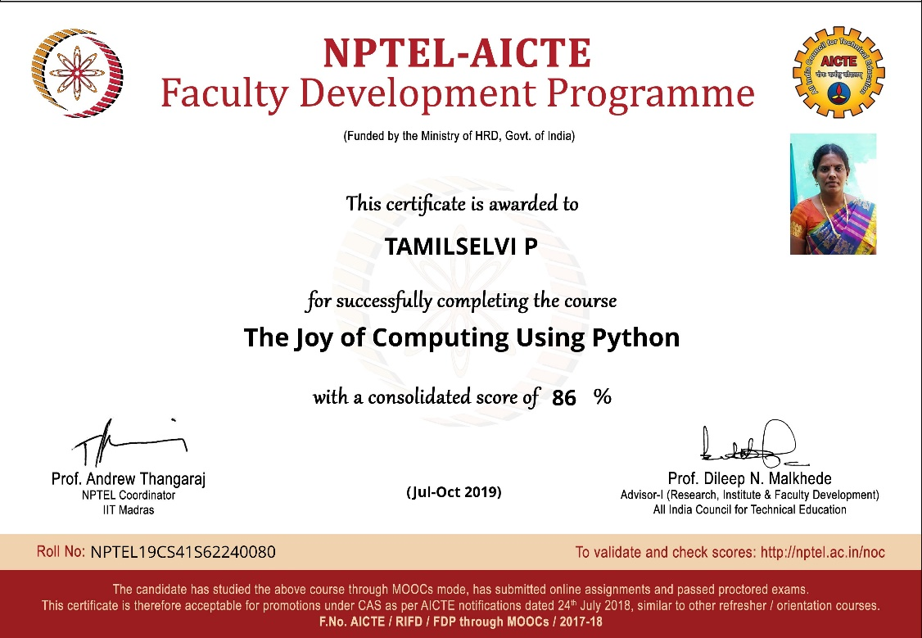

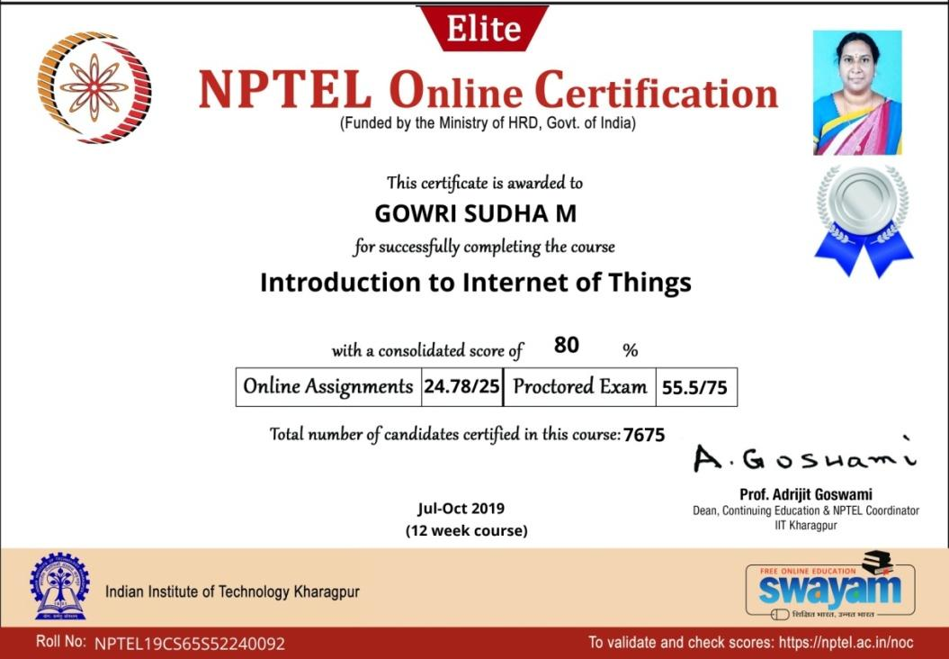

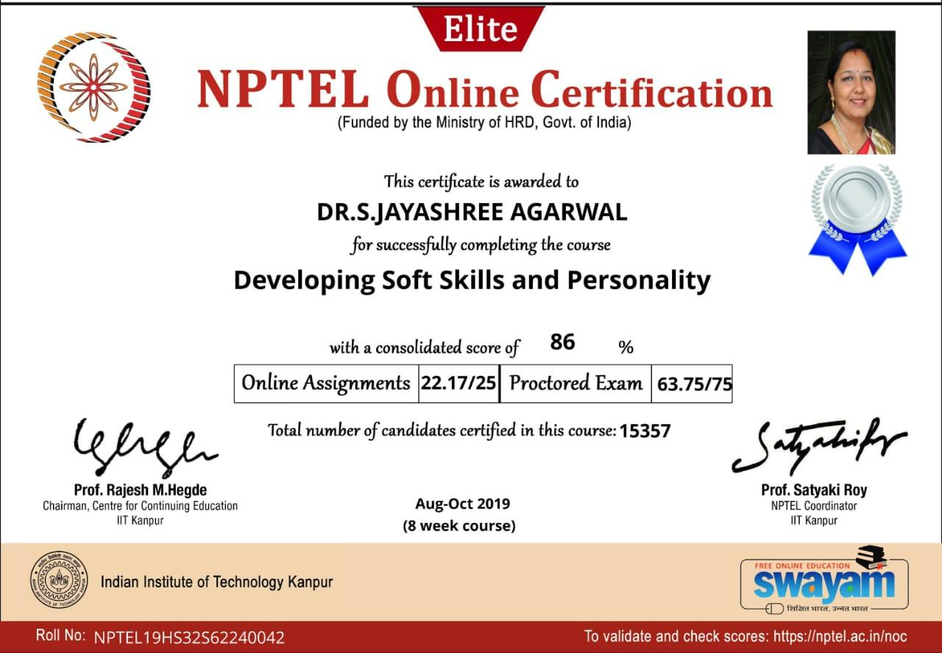

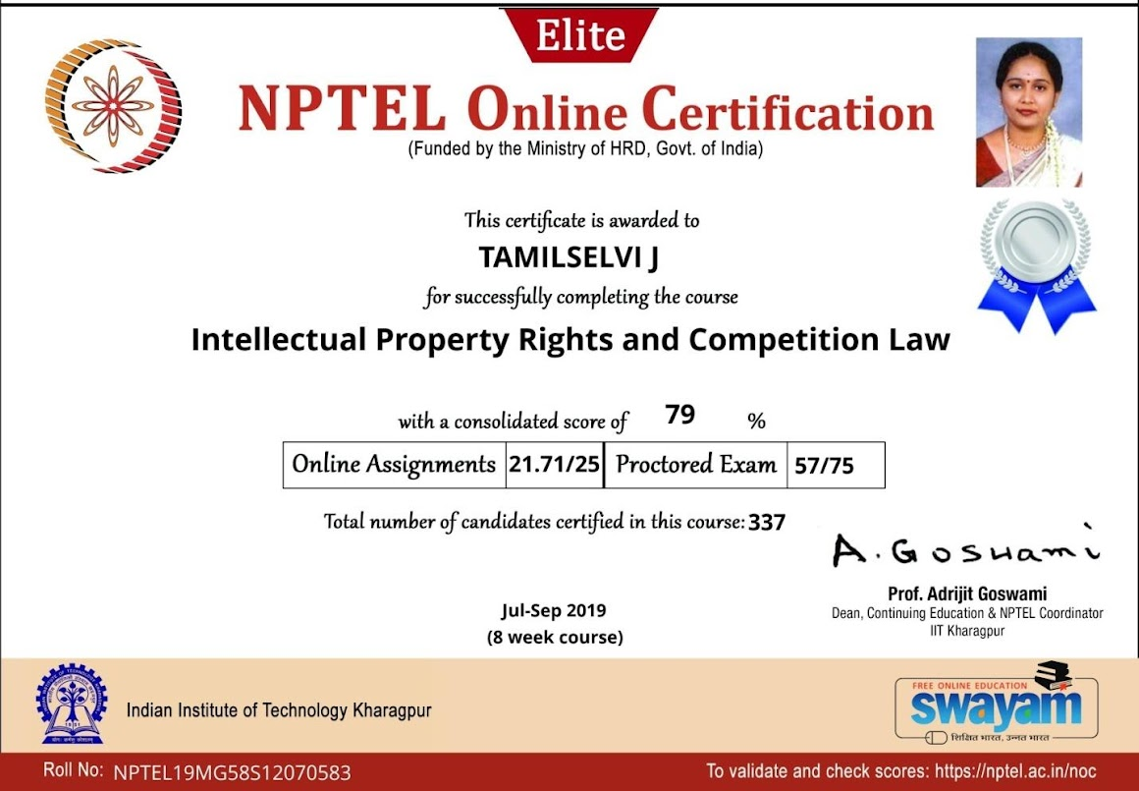

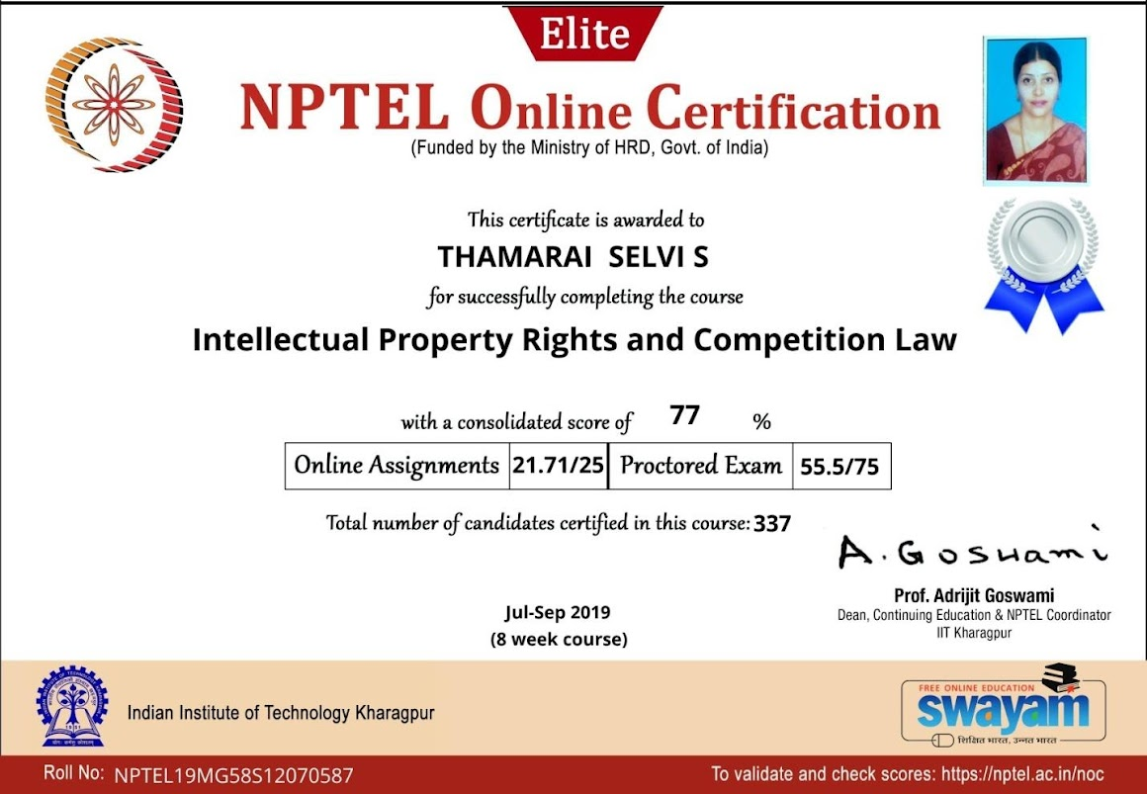

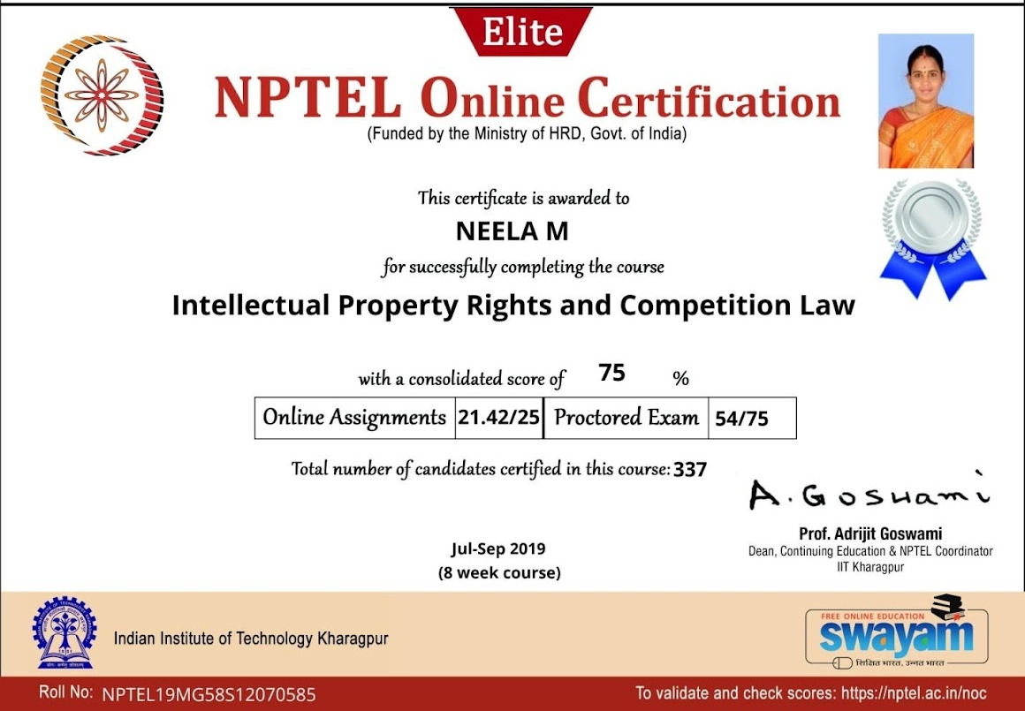

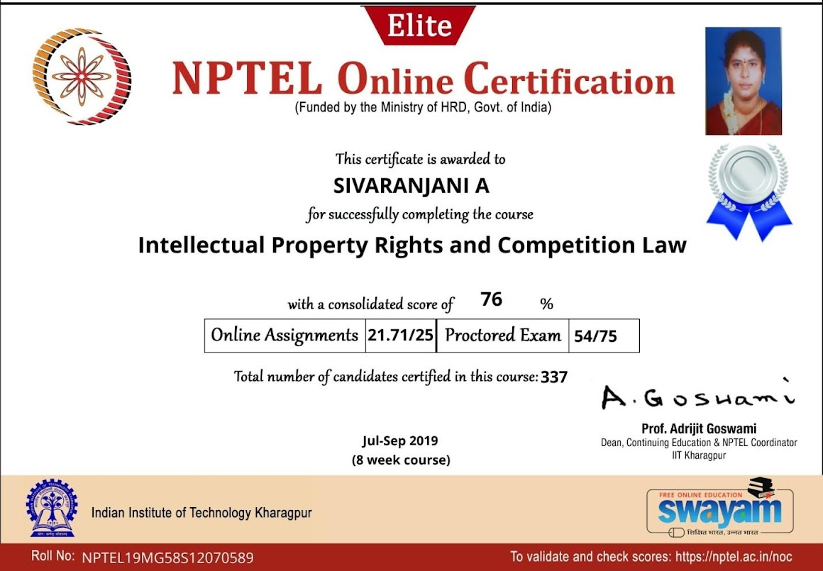

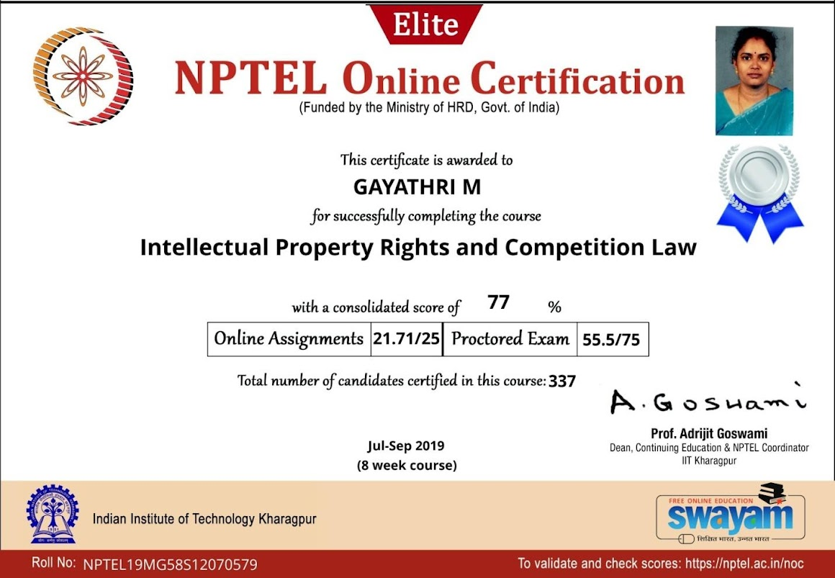

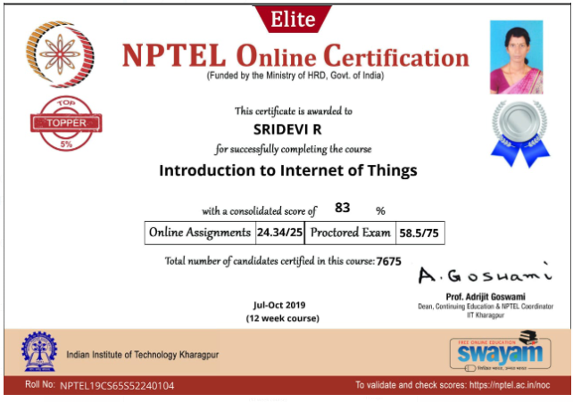

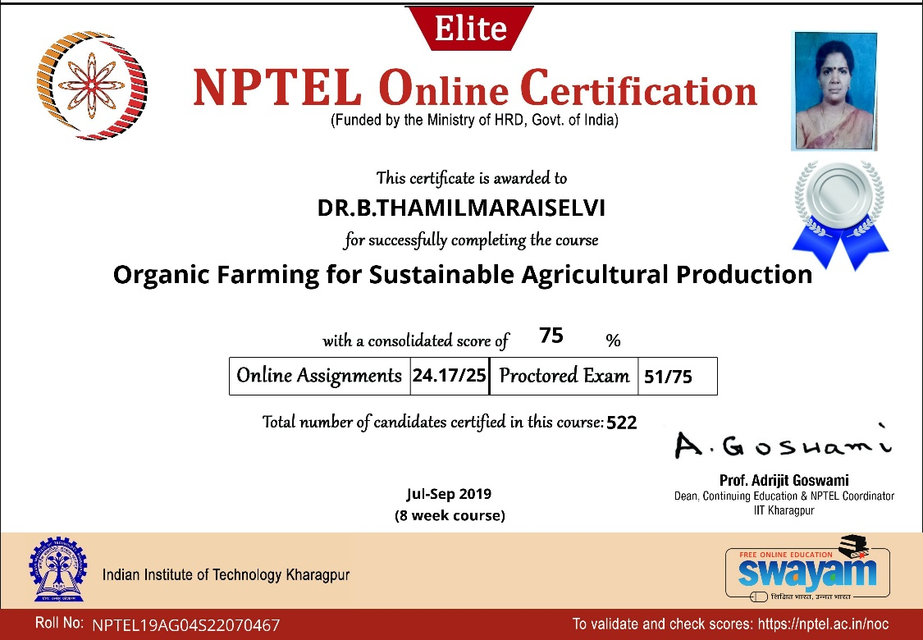

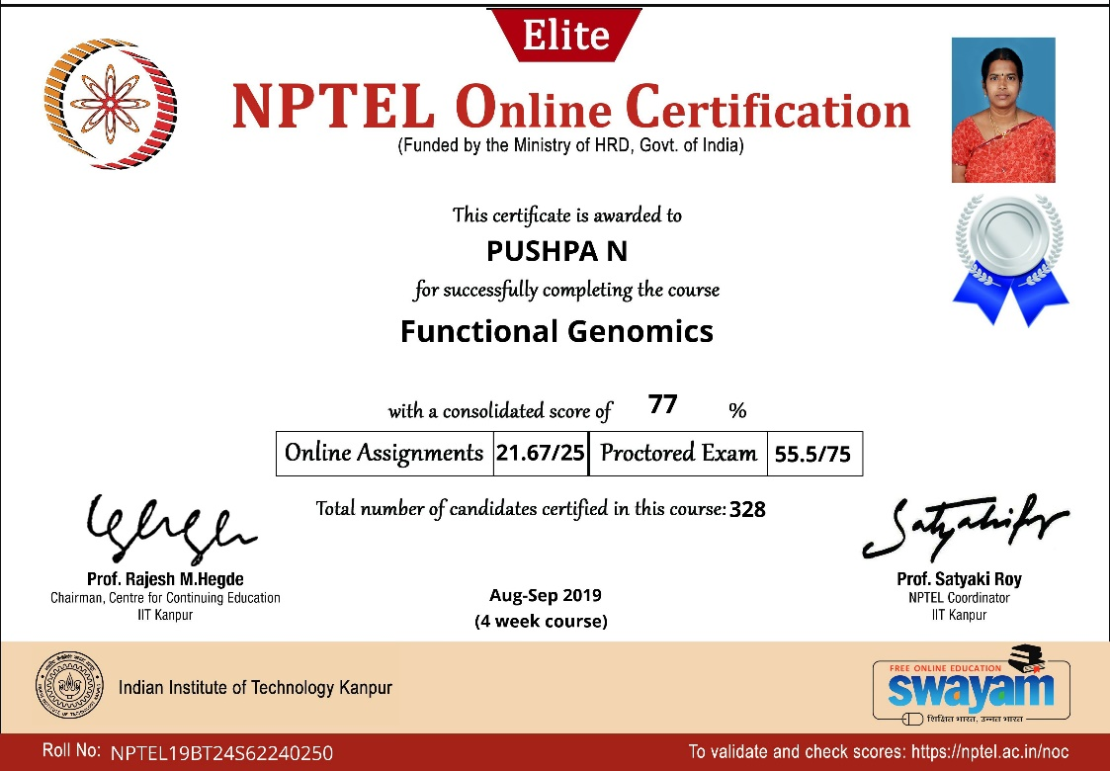

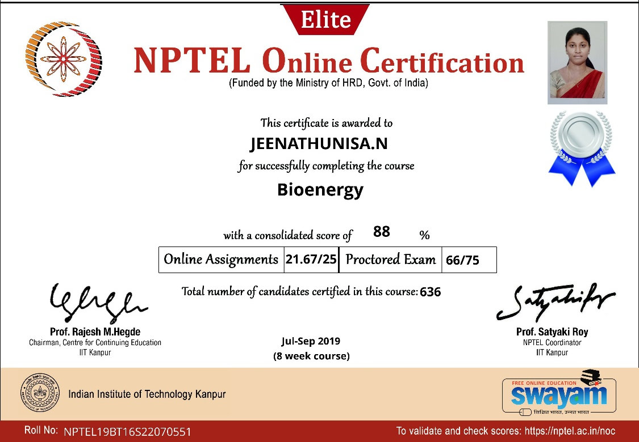

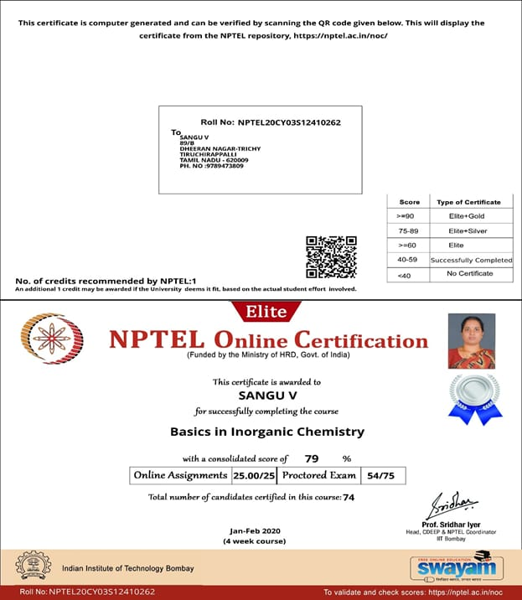

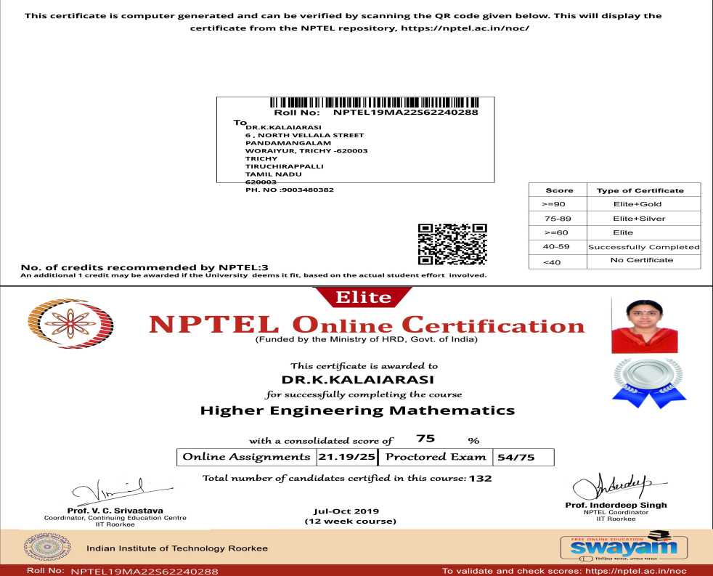

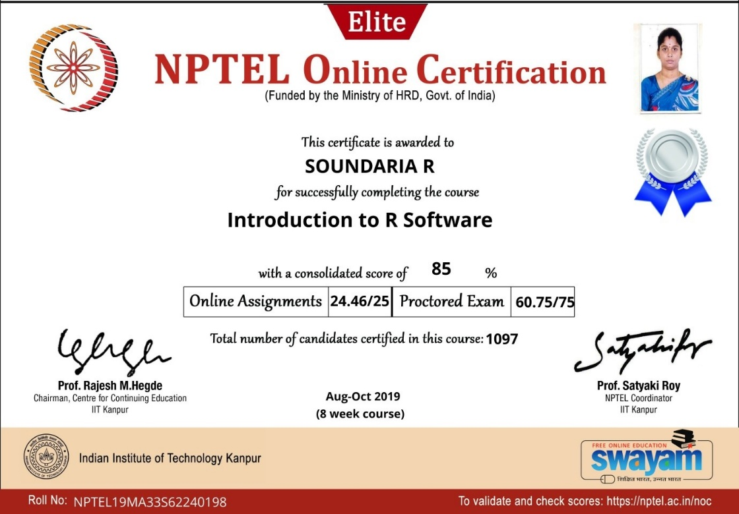

ELITE
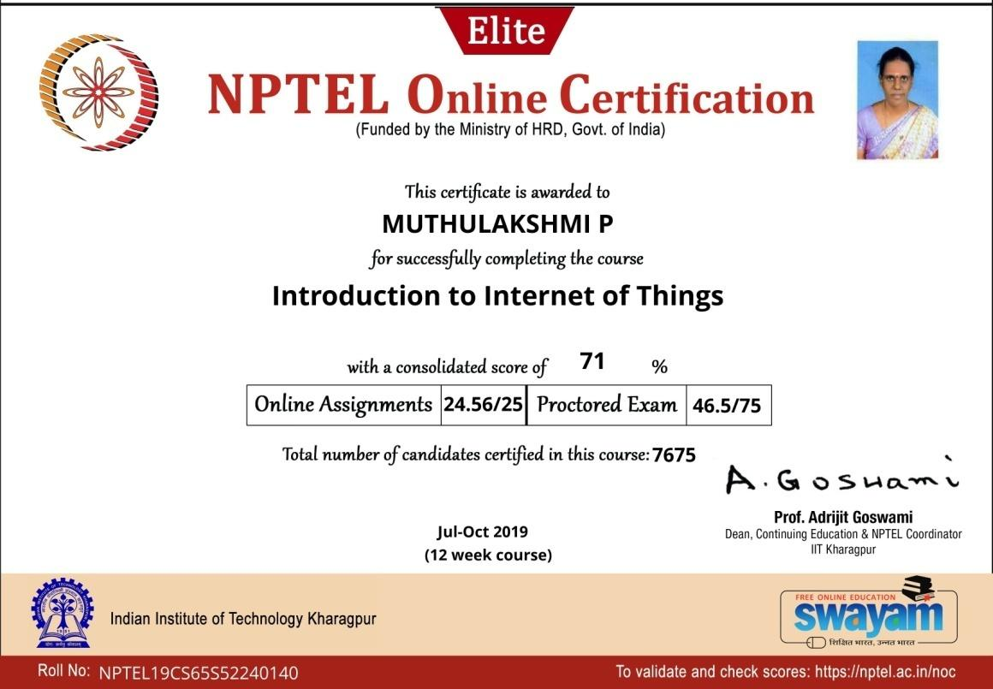

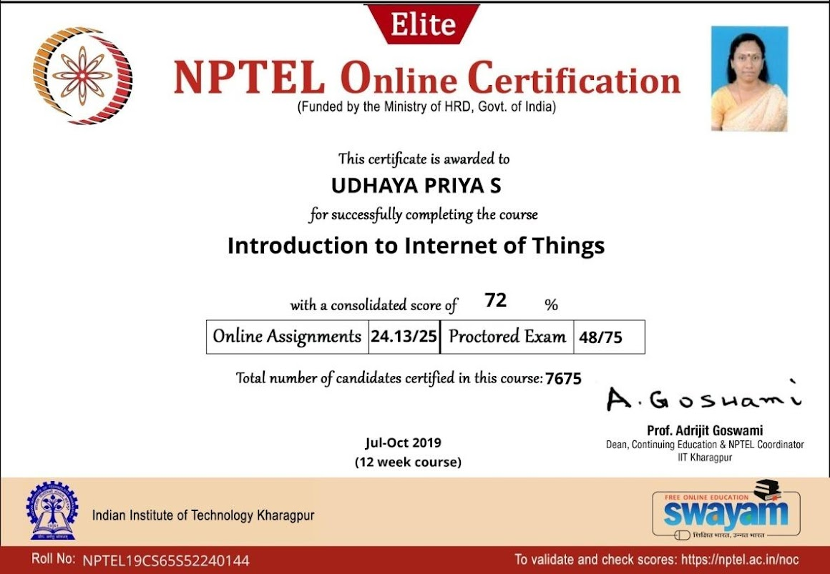

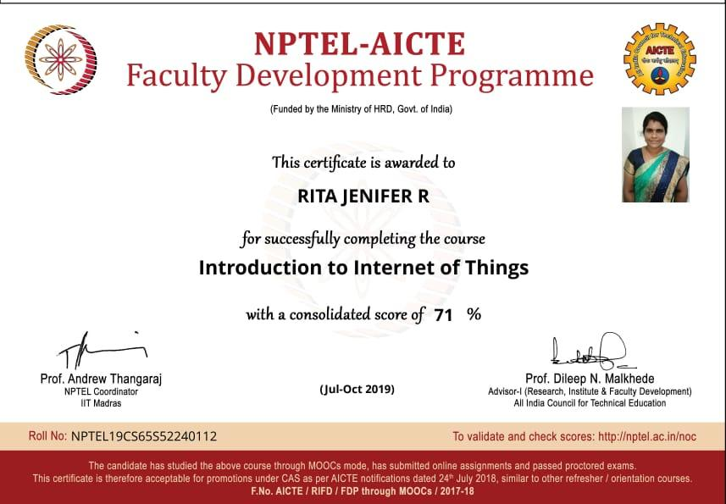

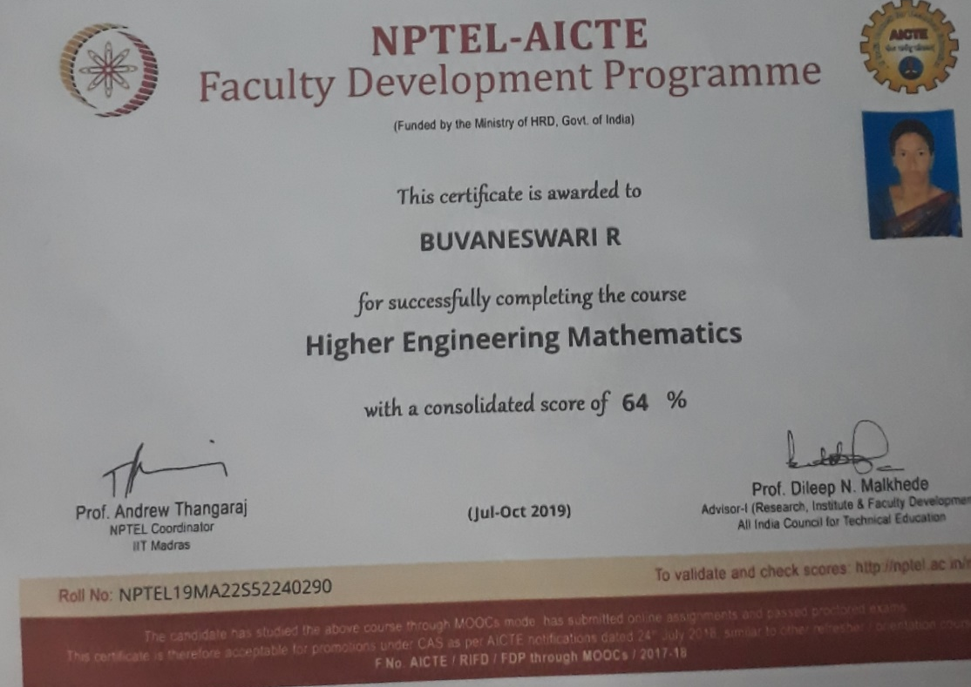

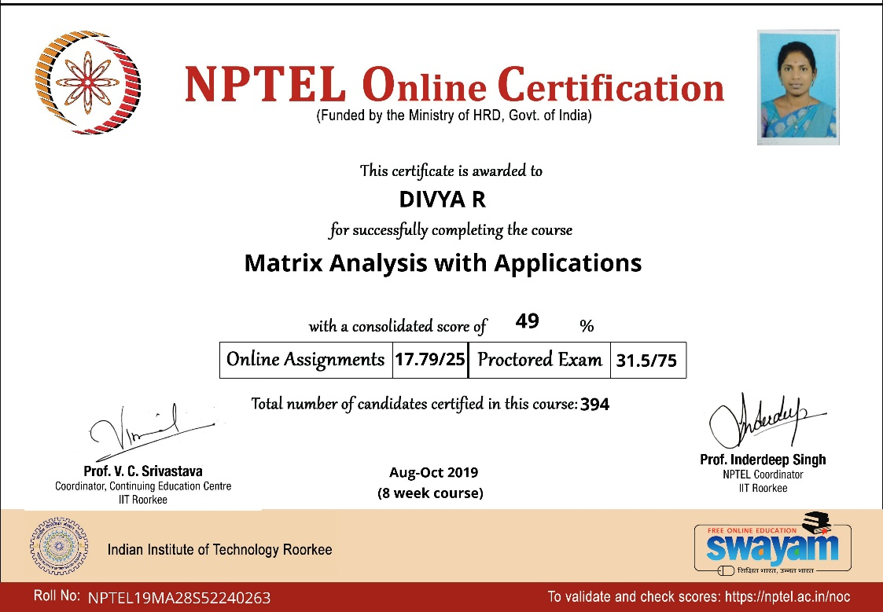

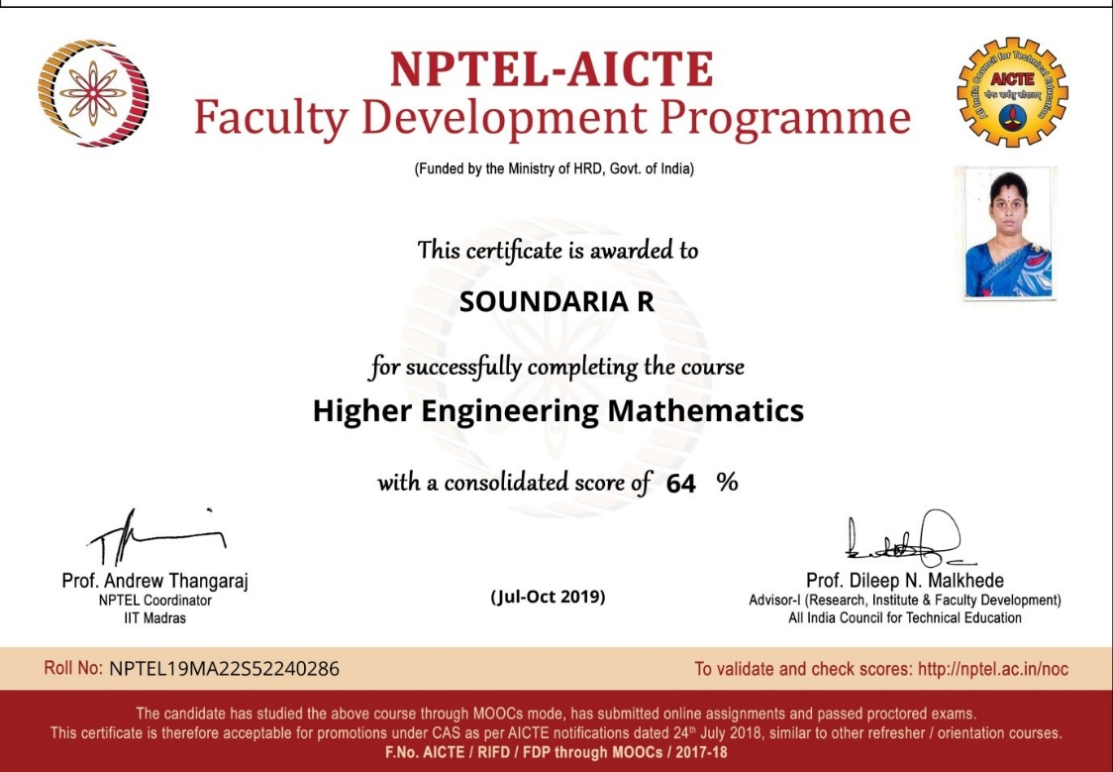

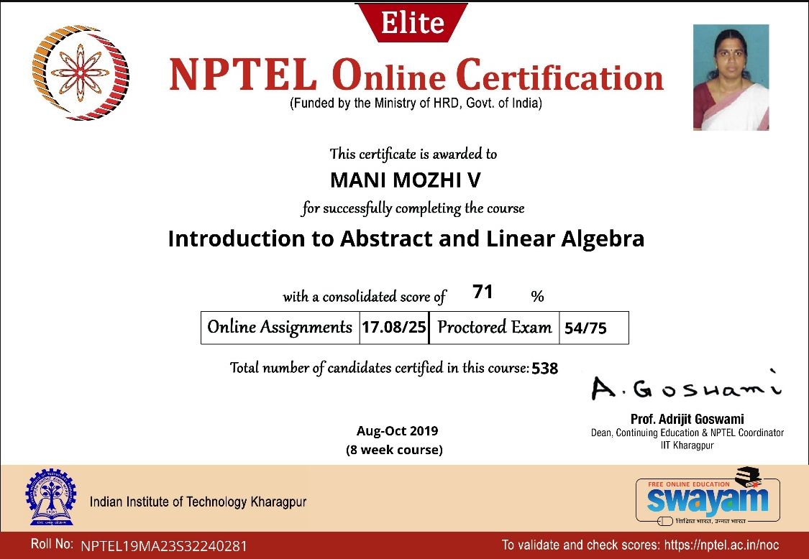

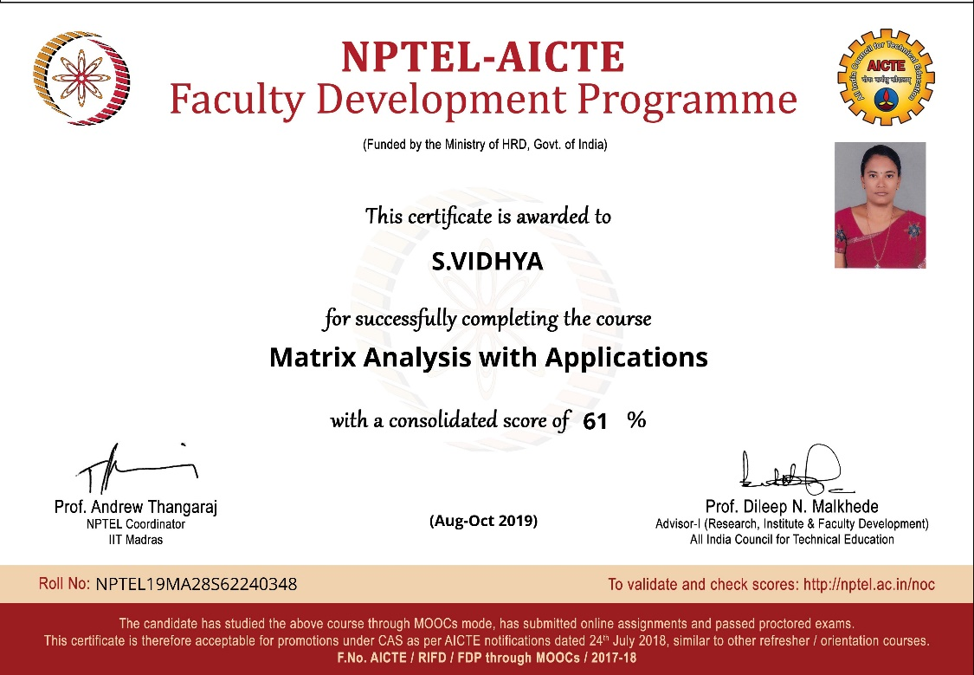

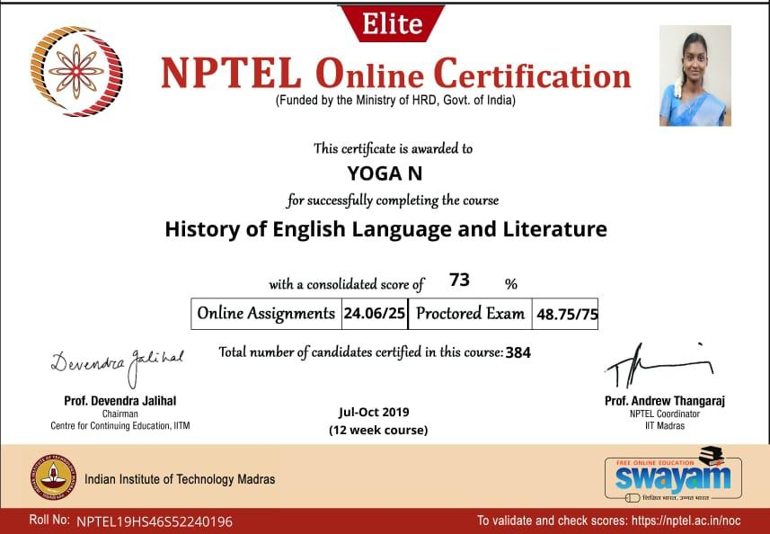

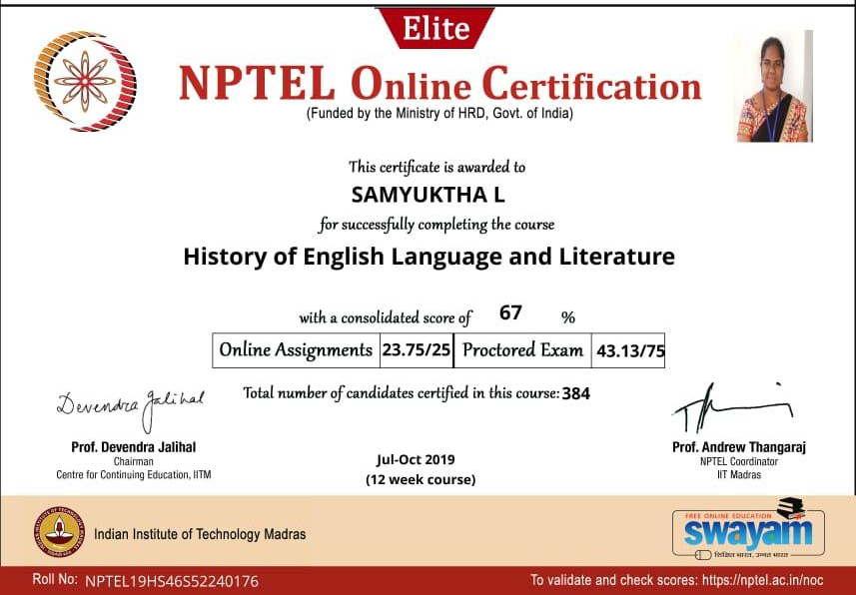

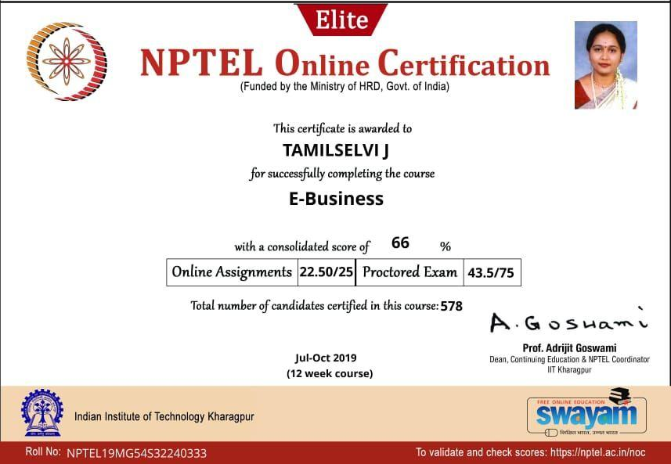

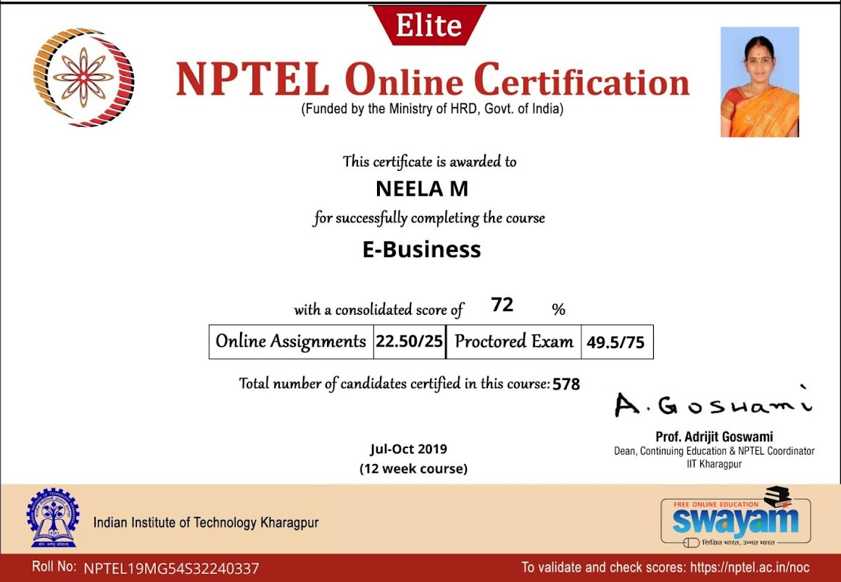

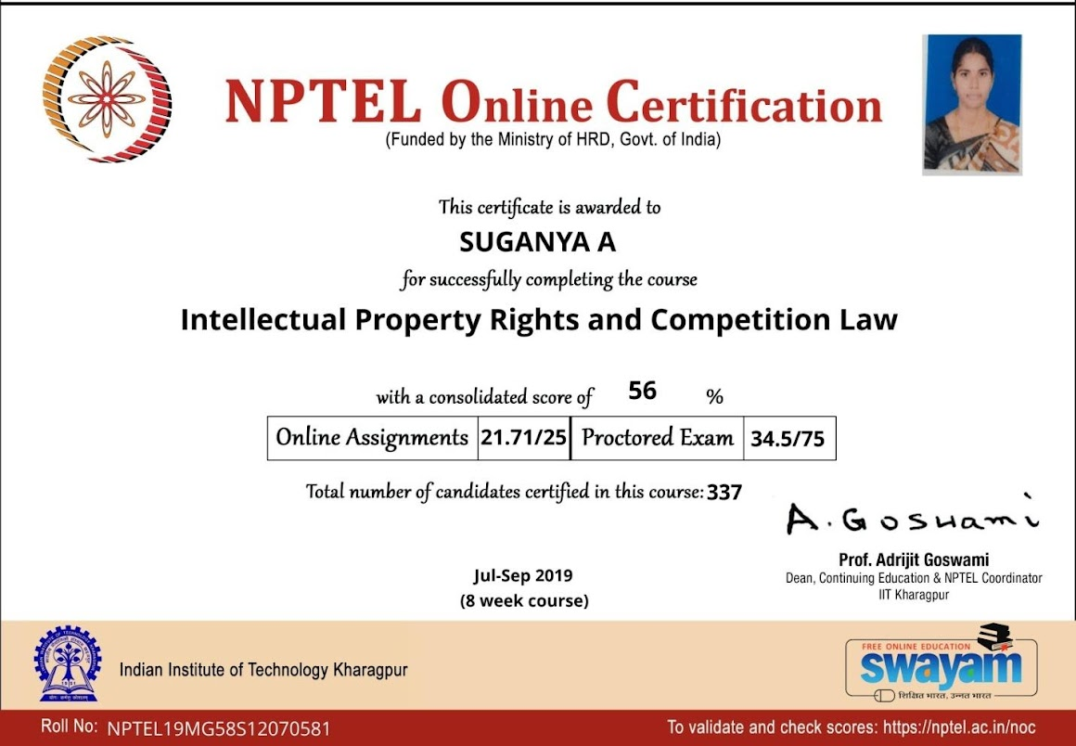

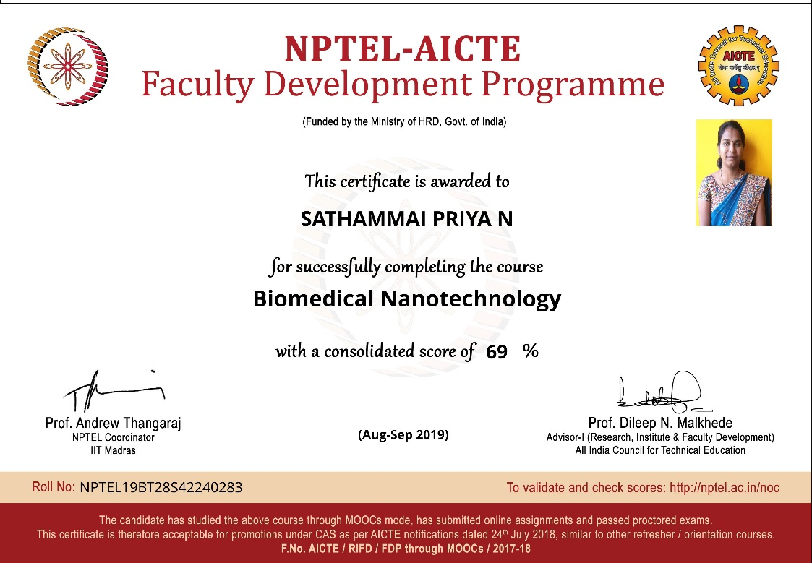

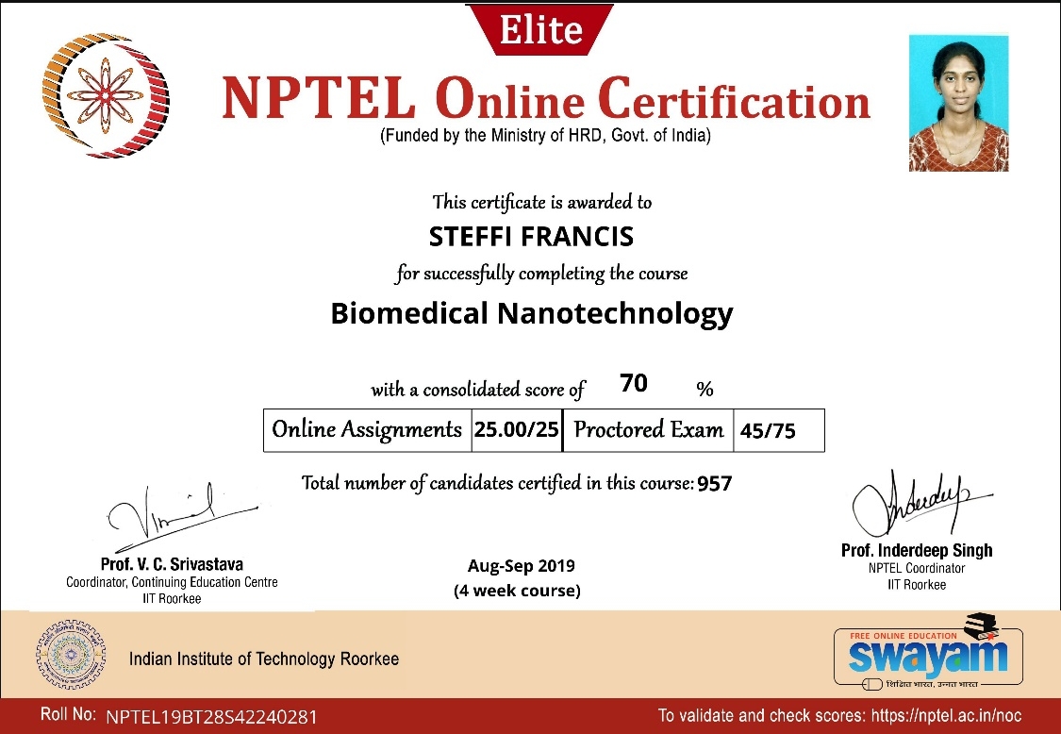

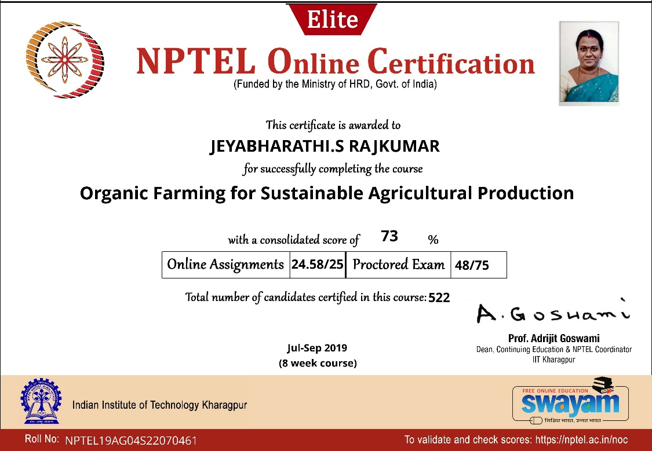

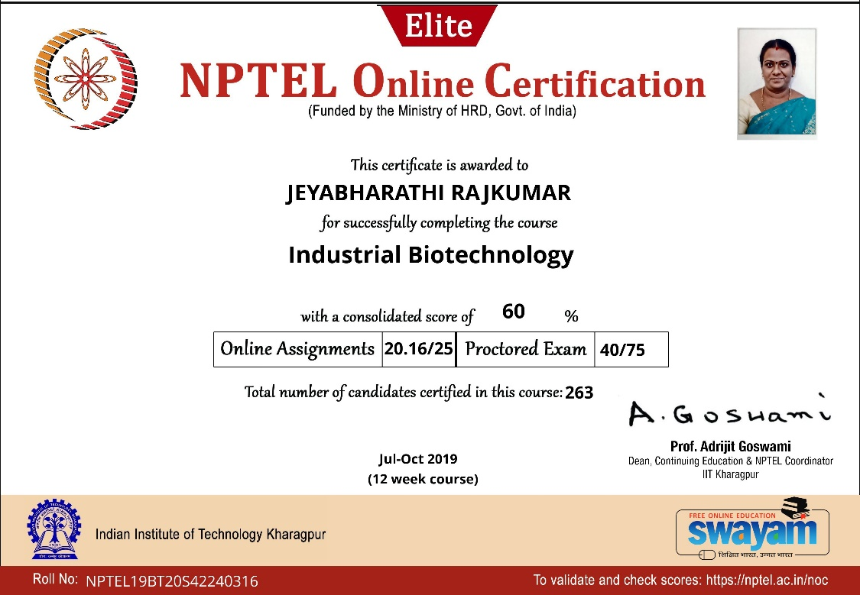

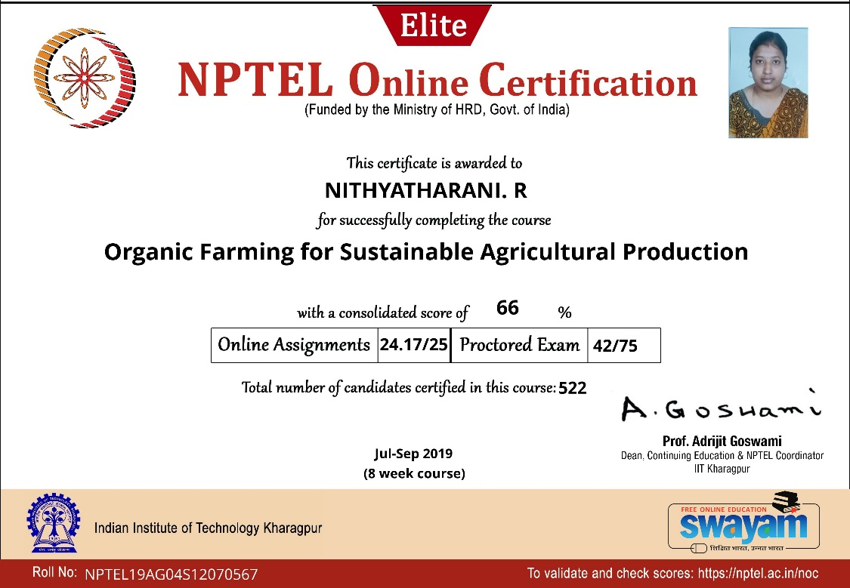

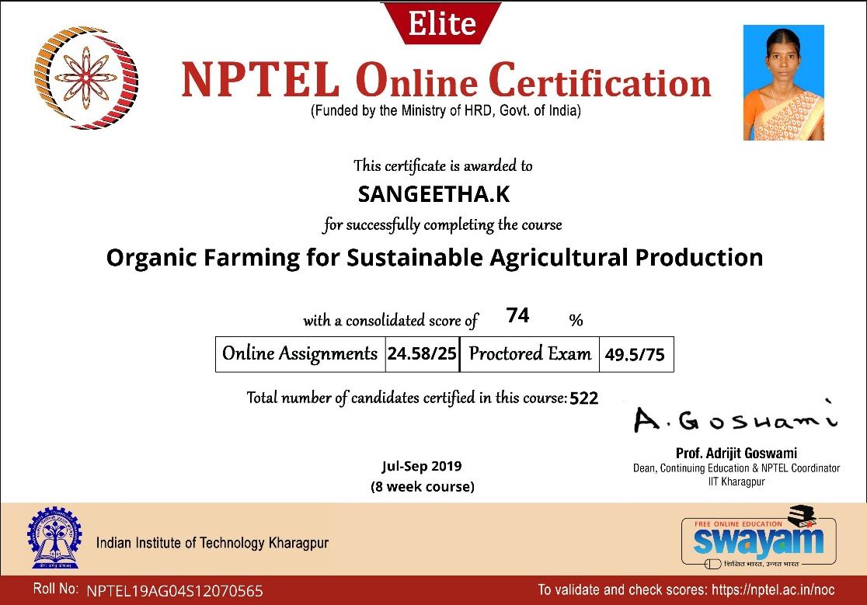

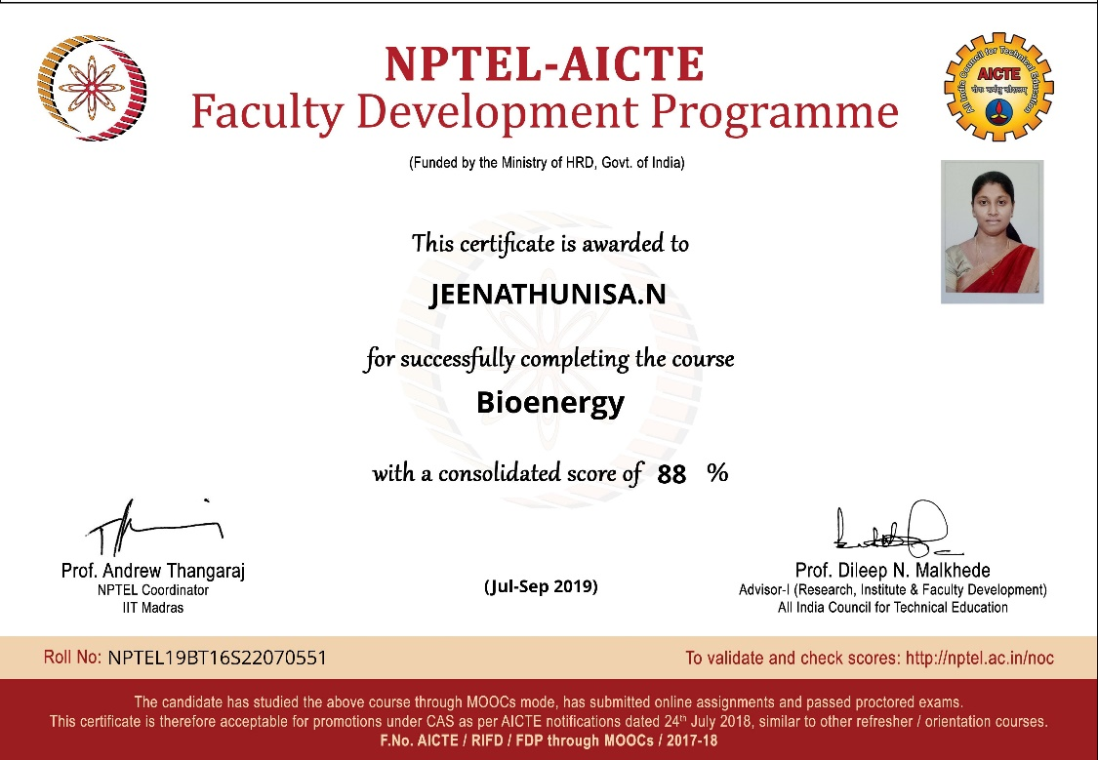

SUCCESSFULLY COMPLETED

