CAUVERY COLLEGE FOR WOMEN (AUTONOMOUS), TRICHY-18
SWAYAM NPTEL - ONLINE COURSE - FACULTY LIST
2021-2022

Number of faculty Registered and Cleared: 17

ELITE + GOLD: 1
ELITE + SILVER with TOPPER: 1
ELITE + SILVER: 4
ELITE: 6
SUCCESSFULLY COMPLETED: 4

NAME | DEPARTMENT | COURSE | GRADE
Ms. S. AGALYA | FSM | Maternal Infant Young Child Nutrition | Elite + Gold
Dr. M. NEELA | Business Administration | Emotional Intelligence | Elite + Silver with Topper
Dr. J. TAMILSELVI | Business Administration | Emotional Intelligence | Elite + Silver
Dr. J. TAMILSELVI | Business Administration | Consumer Psychology | Elite + Silver
Dr. M. NEELA | Business Administration | Consumer Psychology | Elite + Silver
Dr. A. SIVARANJANI | Business Administration | Consumer Psychology | Elite + Silver
Dr. M. GAYATHRI | Business Administration | Consumer Psychology | Elite
Mrs. A. SUGANYA | Business Administration | Consumer Psychology | Elite
Dr. K. KALAIARASI | Mathematics | Big Data Computing | Elite
Dr. P. SUDHA | Mathematics | Numerical Linear Algebra | Elite
Ms. R. SOUNDARIA | Mathematics | Big Data Computing | Elite
Dr S SENTHILKUMARI | English | The Nineteenth - Century English Novel | Elite
Dr. M. KEERTHIGA | Biotechnology | Bioreactors | Successfully Completed
Dr. K. KALAIARASI | Mathematics | Machine Learning, ML | Successfully completed
Dr. K. KALAIARASI | Mathematics | Introduction to Machine Learning | Successfully completed
Dr. R. BHUVANESWARI | Mathematics | Essential Mathematics for Machine Learning | Successfully Completed

ELITE + GOLD

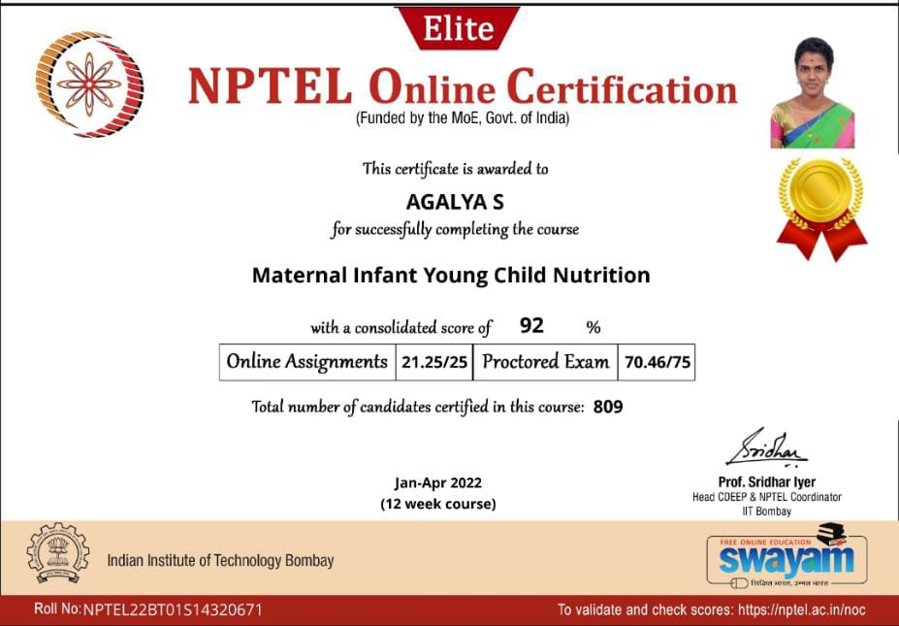

ELITE + SILVER WITH TOPPER
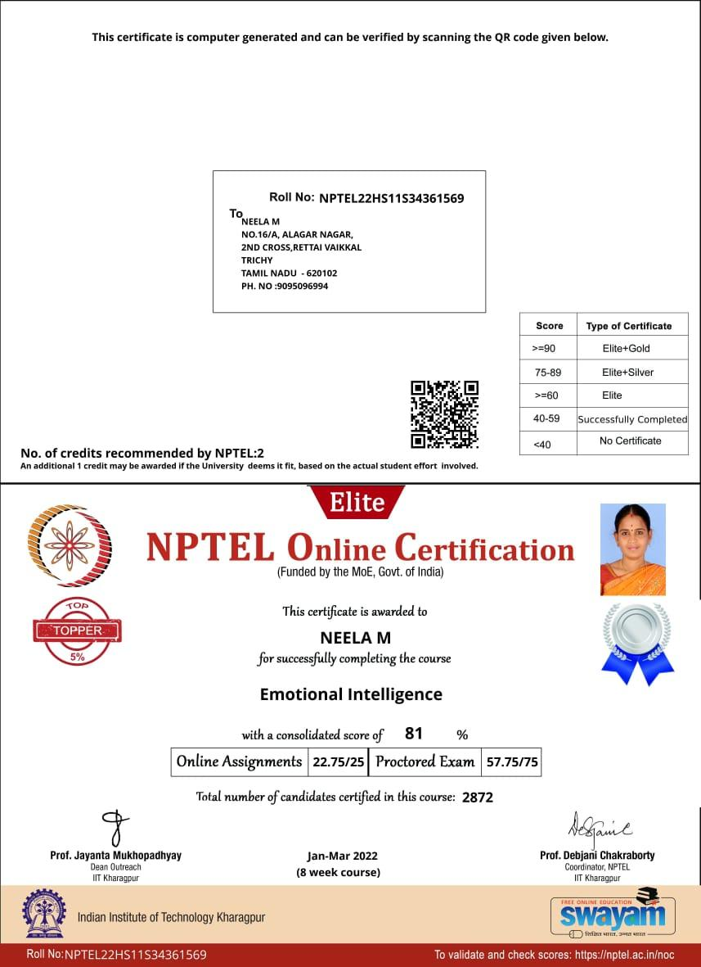

ELITE + SILVER

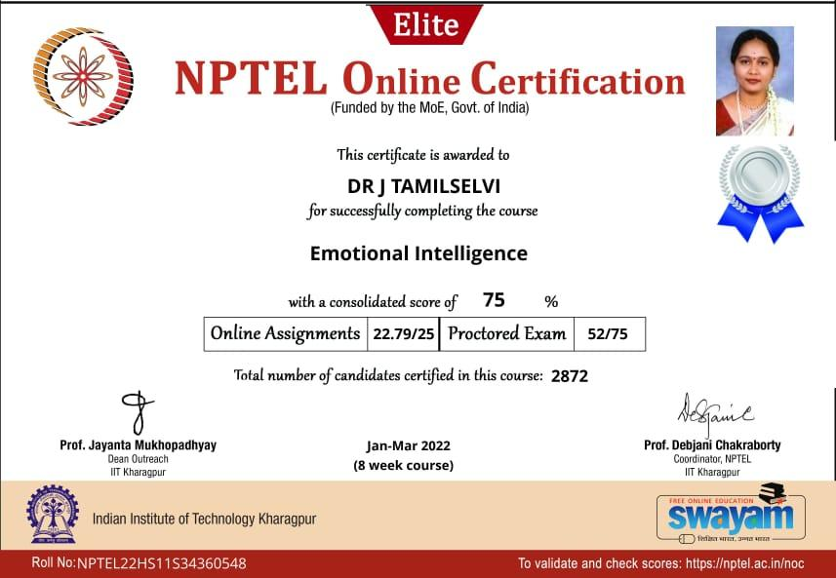

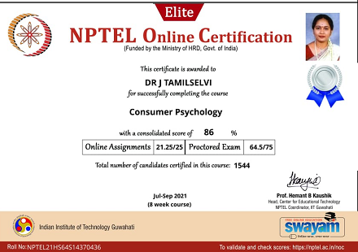

ELITE

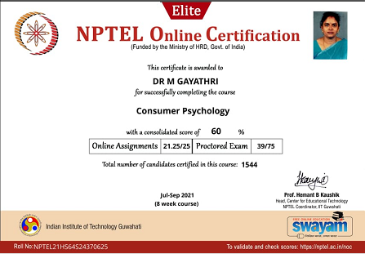

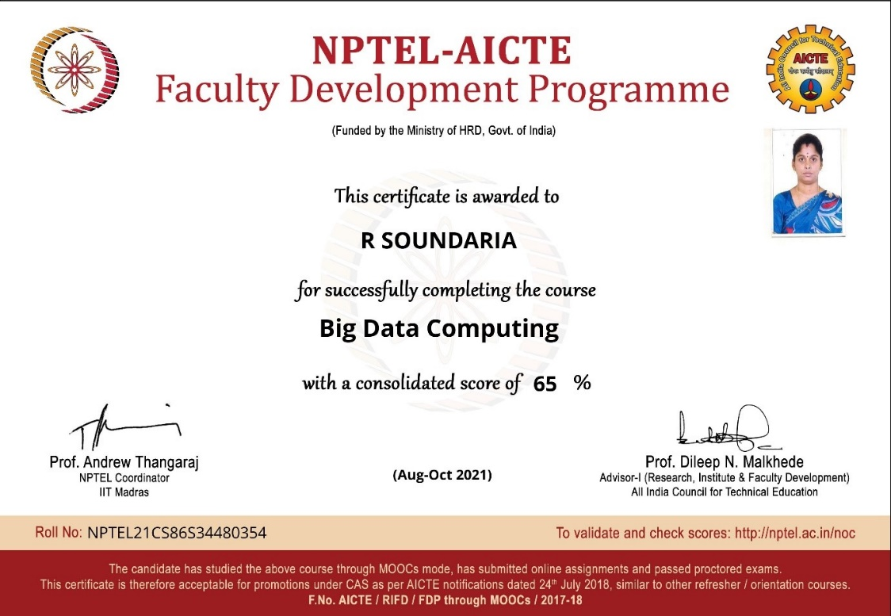

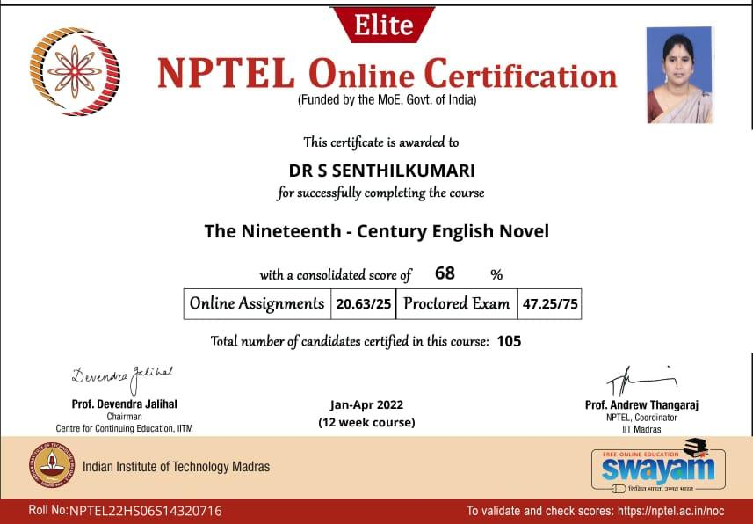

SUCCESSFULLY COMPLETED

